Flagstaff Hill R-7 School

Pedal Prix 2018
General Information Guide

Team Managers:
Paul Broadley ph. 0410 746 655
Steve Blakeborough
Contents

What is Pedal Prix? 3
The vehicles 3
The races 4
6 hour races 4
24 hour race 5
Expectations of riders 6
Expectations of parents 6
Cost 7
Sponsorship and fundraising 7
Training 7
Equipment required 8
Communications 8
Forms 8

What is Pedal Prix?

The UniSA Australian HPV Super Series (Pedal Prix) is staged by Australian International Pedal Prix Inc. and is a competition where teams race three wheel recumbent Human Powered Vehicles (HPV’s) on a closed controlled circuit.
The 2018 series consists of six rounds staged in South Australia and Busselton WA (see ‘The races’).
The 24hr race in Murray Bridge is acknowledged as the biggest and best HPV race in the world attracting 200 teams and 3,200 riders with support crew and spectator numbers in the thousands.
Riding a recumbent tricycle is a very different experience to a normal bicycle and not only involves becoming comfortable with riding in the recumbent position in an enclosed vehicle but also with the steering, gears and braking.
Further information about the UniSA Australian HPV Super Series can be found at www.pedalprix.com.au.

The vehicles

Flagstaff Hill R-7 School has been involved in Pedal Prix since 2001 starting with a single steel frame vehicle and progressing to 2018 where the school will again run two high performance aerodynamic vehicles enclosed in fibreglass and carbon fibre. The Flaggy Flash was purchased in 2016 and the Flaggy Too in 2017.
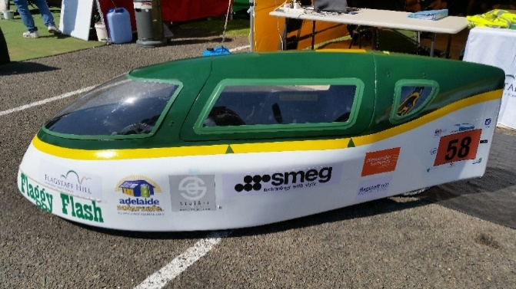
All competing vehicles must comply with a stringent set of specifications designed to ensure they meet the spirit of human powered racing but, more importantly, are safe. They include racing style seat belts, roll cages and protective padding to ensure the rider remains uninjured in the event of a racing incident.
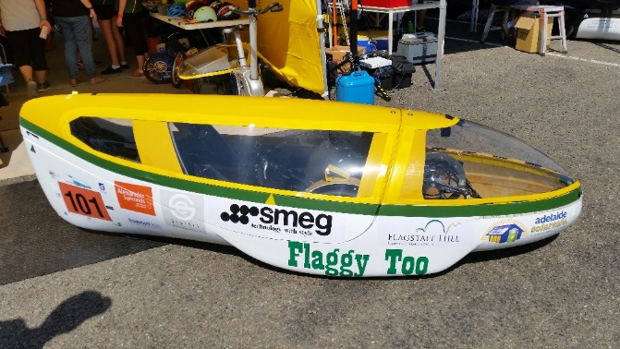

The races

The current Pedal Prix series consists of the following 6 events:
Race 1 April 7 Mt Gambier 8 hour event
Race 2 May 6 Loxton 6 hour event
Race 3 June 16 – 17 Victoria Park 6 hour event
Race 4 July 28 – 29 Victoria Park 6 hour event
Race 5 August 19 Busselton, WA 6 hour event
Race 6 September 22 – 23 Murray Bridge 24 hour event
In 2018, Flagstaff Hill R-7 School has again registered to compete in both of the 6 hour races at Victoria Park and the 24 hour race in Murray Bridge.
However, we are also exploring the option of racing in Loxton this year for the first time although this will be based entirely on rider/parent interest and will attract an additional cost.
Within each race, teams are placed in one of the following categories:
Cat 1 Upper primary schools
Cat 2 Lower secondary schools
Cat 3 Upper secondary schools
Cat 4 Open
In the Victoria Park races, Cat 4 competes on the Saturday and Cat 1, 2 & 3 on the Sunday. In all other races (including the Murray Bridge 24 hour race), all categories compete together.

6 hour races

Each 6 hour race at Victoria Park runs from 10am until 4pm and entry to the circuit is free.
At Flagstaff Hill R-7 School, riders generally placed into groups of 3 or 4 in each of the 6 hour races and each group rostered to ride for a period of 2 hours. This means each rider will generally ride for 15 – 20 mins twice. Riders and an adult guardian are expected to arrive at least 30mins prior to their rostered group time and be present at the race for the entire 2 hour period their group is riding.
Riders will be allocated to a vehicle for the first race and are generally swapped for the second race so they have an opportunity to try both.
Parent assistance is required on race day for:
- team pit area set up and pack up
- pit crew
- timing
- marshalling.
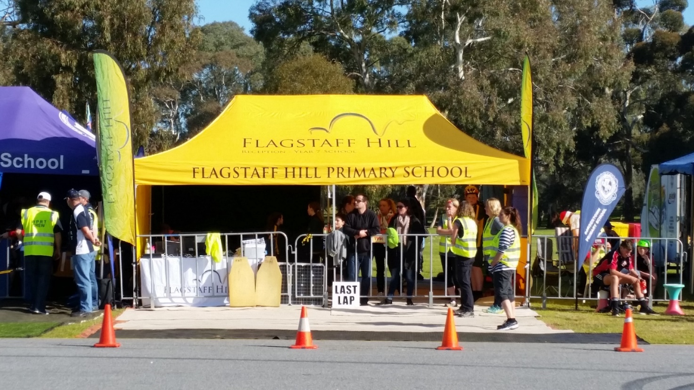

24 hour race

The 24 hour race is held in Sturt Reserve, Murray Bridge and has all categories racing together meaning there are approximately 200 vehicles on the track with some significant speed differences. However, many of the faster teams are highly skilled at manoeuvring and serious incidents are rare.
The event includes a 1 hour timed practice session on the Friday evening. The 3 teams from each category with the fastest single practice lap plus the 3 fastest all-female teams then complete a top 15 shootout on the Saturday morning to determine the first 15 grid placings. All other teams are ranked based on their fastest single practice lap time. The race commences at 12pm Saturday and finishes at 12pm Sunday.
At Flagstaff Hill R-7 School, riders will be allocated to a vehicle for this race based predominantly on their performance in the 2 shorter races but also their commitment to practice and general attitude. They will be placed into groups of 3 or 4 and each group rostered for 4 periods of 2 hours, including throughout the night. Riders and an adult guardian are expected to be present for the entire duration of the race.
As the Friday practice session is the only opportunity riders will have to ride the circuit prior to the race, families are encouraged to travel to Murray Bridge that day and stay in the designated camping area inside the circuit until the conclusion of the race on Sunday.
In 2017, an entry fee of $15 was payable for every person (including riders but excluding children under 10yo) to enter the circuit. In addition, every vehicle attracted an entry fee of $15. It is expected that a similar fee will be payable in 2018.

Parent assistance is required over the weekend for:
- transporting equipment to and from Murray Bridge
- team pit area set up and pack up
- pit crew
- timing
- marshalling
- catering, cooking and cleaning up.
More specific information about the 24 hour race will be provided approximately 4 weeks prior to the event but feel free to ask Paul or Steve questions at any training session or race.
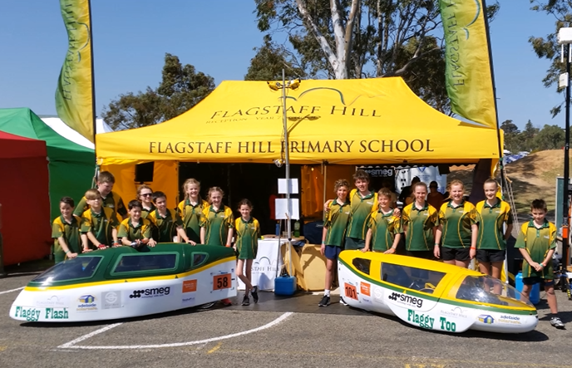

Expectations of riders

The predominant expectation of all riders is that they have a positive attitude and a genuine desire to perform to the best of their ability.
In addition, every rider is expected to:
- attend as many of the rostered bi-weekly before school training sessions as possible
- attend the rostered weekend training sessions
- attend races during their rostered ride time and support their team mates
- work on their personal cycling fitness in their own time
- push themselves to perform at their best, display team work and represent Flagstaff Hill R-7 School with pride at all races.

Expectations of parents

Everyone involved in running the Flagstaff Hill R-7 School Pedal Prix team, including school staff, are volunteers. As such, the predominant expectation of all parents is that they help as much as possible including:
- being involved in the organisation and running of training and events including pit crew, timing and marshalling
- assisting with race day set up/pack up
- assisting with identifying and coordinating fundraising opportunities
- ensuring riders attend training sessions and races on time
- helping riders with personal training and performing to the best of their ability.
- supporting and encouraging their child to challenge themselves.

Cost

As per the notice sent home with interested students in December 2017, fees for 2018 have been set at $210 per rider.
This fee includes:
- team registration
- a jacket for the rider
- catering for each rider and family of 4 ($15 per extra person) at the 24 hour event from breakfast on Saturday to breakfast on Sunday
- trophies.

Sponsorship and fundraising

With entry fees of almost $3,000, vehicle parts and maintenance costing around $1,000 and pit setup costs at the 24 hour event of approximately $1,800, Pedal Prix is not a cheap sport.
Whilst the school provides some funding, the shortfall must predominantly be made up from sponsorship and fundraising.
Sponsorship can be either financial or in goods and services which can be raffled or help reduce running costs. In return, sponsors names are displayed on both vehicles and the school trailer in a size relative to the size of sponsorship as well as included in team communications.
A variety of fund raising events are planned for 2018 including Bunnings BBQs and raffles.
Parent assistance in identifying sponsors and running fundraising events is vital to ensuring the Flagstaff Hill R-7 School Pedal Prix program can be run to the benefit of all riders. Please speak with Paul or Steve if you have ideas for sponsors or fund raising.

Training

Personal fitness is an important part of Pedal Prix and riders are expected to build their own fitness through dedicated training. As such, the following training sessions will be programmed throughout the year:
- Tuesday and Thursday mornings from 8:00 – 8:30 during each term run by Jamie Burnside and Kylie Broadley
- Specific weekend practice sessions on the blue courts at school using the vehicles
- Scheduled weekend practice sessions at Victoria Park.
Riders are expected to attend as many practice sessions as possible including a minimum of 1 weekend session prior to each race as this ensures riders are familiar with the vehicles and their riding position is confirmed. The following weekend practice sessions are currently planned (weather permitting):
Date Location
8 April At school
29 April TBA
27 May Victoria Park
3 June Victoria Park
1 July Victoria Park
22 July Victoria Park
26 August Victoria Park

Equipment required

The following equipment is mandatory for all riders:
- A good quality bike helmet (meeting Australian Safety Standards) in good condition with no cracks in the foam or outer cover. Helmets will be checked prior to allowing riders to enter the vehicles.
- A drink bottle that fits a standard bicycle bidon cage.
- School polo or SAPSASA shirt
The following equipment is also recommended:
- Cycling gloves
- Sunglasses
- Bike pants or shorts (inside of vehicles can get warm)

Communications

To ensure communications are received by parents in the most effective manner, all Pedal Prix notices and updates will be posted on the Pedal Prix Blog - https://flaggypedalprix.edublogs.org.
We are also exploring with the school the option of establishing a private Facebook page that can be used to share information and provide updates at short notice.

Forms

The following forms are required to be completed by riders and their parent before they will be permitted to race:
- General information form
- Medical information form
- Indemnity form required by the Australian International Pedal Prix (AIPP).
In addition, if you are willing to volunteer as a marshal, please ensure you have completed the indemnity and training available on the Pedal Prix website – http://pedalprix.com.au/marshals/.

