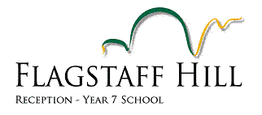
Pedal Prix 2018 - Loxton

Hello

The following information relates specifically to the Loxton round of the Pedal Prix series.

What: 6hr race – all categories

When: Sunday 6th May 2018 from 10am to 4pm

Where: Loxton SA, approx. 260km (3hrs) from Flagstaff Hill

Cost: Race entry is $385 per team

Proposal:

- We will race a single vehicle (Flaggy Too)
- The team will be limited to a minimum of 9 and maximum of 12 riders (first in, first served)
- The entry fee will be paid for by the riders (i.e. between $32 and $42 each)
- Each rider and family will make their own way to the event
- All riders and their guardian would be expected to be at the event for the entire race (including pit set up and pack up)
- Catering for breakfast and/or lunch at an additional cost could be an option if someone is willing to organize
- Weekend training sessions on 8th and 29th April would be compulsory for these riders to ensure they are comfortable in the vehicle beforehand.

Given the location and timing of this event, it is a significant commitment for everyone involved so please only indicate your interest if it is genuine.

If you are seriously interested, the consent form and payment must be returned by 6 April.

To ensure costs are covered, we will not enter the race until all monies have been paid. If we do not go ahead with the entry, any money paid up to that point will be refunded.

Paul Broadley and Steve Blakeborough
Team Managers

