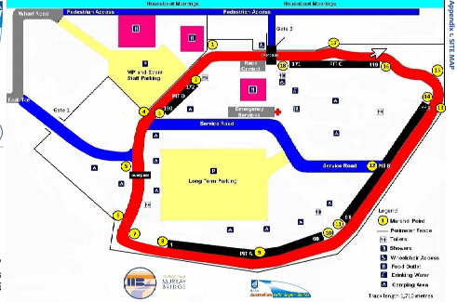

Our pit area (176 and 177) Our Marshal Points

